Prototype Model

Definition and Concept
The prototype model requires that before carrying out the development of actual software, a working prototype of the system should be built. A prototype is a toy implementation of the system. A prototype usually turns out to be a very crude version of the actual system, possible exhibiting limited functional capabilities, low reliability, and inefficient performance as compared to actual software.
Main Characteristics
Prototypes have 4 main qualities: Representation — The actual form of the prototype, i.e., paper and mobile, or HTML and desktop. Precision — The fidelity of the prototype, meaning its level of detail, polish, and realism.

Steps of Prototype Model
- Requirement Gathering and Analyst
- Quick Decision
- Build a Prototype
- Assessment or User Evaluation
- Prototype Refinement
- Engineer Product

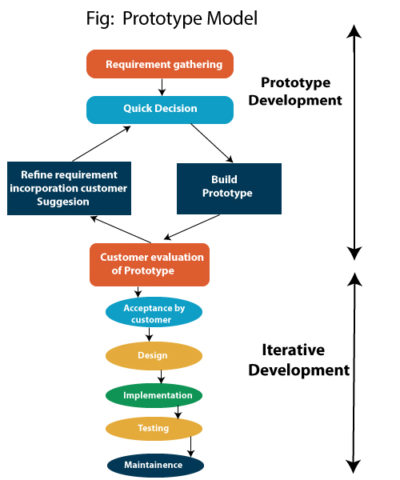

Advantage of Prototype Model
- Reduce the risk of incorrect user requirement
- Good where requirements are changing/uncommitted
- Regular visible process aids management
- Support early product marketing
- Reduce Maintenance cost.
- Errors can be detected much earlier as the system is made side by side.

Disadvantage of Prototype Model
- An unstable/badly implemented prototype often becomes the final product.
- Require extensive customer collaboration
  - Costs customer money
  - Needs committed customer
  - Difficult to finish if customer withdraw
  - May be too customer specific, no broad market
- Prototyping tools are expensive.
- Special tools & techniques are required to build a prototype.
- It is a time-consuming process.

Types of prototype models
There are a few types of prototype models that can be implemented by development teams based on their needs:
- Rapid throwaway- This method involves exploring ideas by quickly developing a prototype based on preliminary requirements that is then revised through customer feedback. The name rapid throwaway refers to the fact that each prototype is completely discarded and may not be a part of the final product.
- Evolutionary- This approach uses a continuous, working prototype that is refined after each iteration of customer feedback. Because each prototype is not started from scratch, this method saves time and effort.
- Incremental- This technique breaks the concept for the final product into smaller pieces, and prototypes are created for each one. In the end, these prototypes are merged into the final product.
- Extreme- This prototype model is used specifically for web development. All web prototypes are built in an HTML format with a services layer and are then integrated into the final product.

Difference between Waterfall model and Prototype model

S.No. | WATERFALL MODEL | PROTOTYPE MODAL
1. | Waterfall model is a software development model and works in sequential method. | Prototype model is a software development model where a prototype is built, tested and then refined as per customer needs.
2. | It give emphasis on risk analysis. | It does not give emphasis on risk analysis.
3. | There is high amount risk in waterfall model. | It is suitable for high-risk projects.
4. | In this, quick initial reviews are possible. | In this, quick initial reviews are not possible.
5. | It is best suited when the customer requirements are clear. | It is best suited when the requirement of the client is not clear and supposed to be changed.
6. | In this user Involvement is only at the beginning. | In this user involvement is high.
7. | It supports automatic code generation as. results in minimal code writing. | It does not support automatic code generation.
8. | The complexity of an error increases as the nature of the model each phase is sequential of the other. | The complexity of an error is low as the prototype enables the developer to detect any deficiency early at the process.
9. | Flexibility to change in waterfall model is Difficult. | Flexibility to change in prototype model is Easy.

